Genetics with a Smile

Teacher Notes
Materials Needed:
Two coins (penny, poker chip, etc.) per student - One marked F for female and one marked M for male
Copies of student worksheets - Genetics with a Smile, Smiley Face Traits, & Wrapping It Up
NOTE: I copy the first two worksheets on one page front/back. I also copy the two pages of the Wrapping It Up worksheet front/back on one piece of paper. I also display a copy of the Smiley Face Sample in the room rather than make copies for every student.
Microsoft Word & printers
NOTE: If you do not have access to Microsoft Word, the students can draw the smiley faces by hand. Crayons or colored pencils
Directions:
- After students have read the instructions on the worksheet, provide two coins for each student. The coin marked F represents the female parent and the one marked M represents the male parent. Students need to flip both coins for each trait and record the results in the chart by circling the correct allele. Students will need to complete the genotype for each trait then refer to the “Smiley Face Traits” page to determine the phenotype.
NOTES:
  - You might consider having students form pairs to complete the project rather than having each student work alone. Since I am assessing the use of technology in addition to genetics, I have each student create a smiley face.
  - Share the sample Smiley Face (next page of this download) with the students and ask them to give the correct genotype for several of the smiley face’s traits using the Smiley Face Traits page.
Possible questions ...
    - What genotypes could result in a smiley face with star eyes? XXXXXXEE or Ee
    - Give the phenotype for a smiley face with the genotype Tt for its smile. XXXXXXXThick smile
    - Is this smiley face a female or male? How do you know? Female - pink bowXXXXXXXXXXX
    - Does the smiley face include any recessive traits? If so, what are they? Yes, curly hair, red XXXXXXXXXXX
eye color, thin mouth, and nose pointing up are all recessive traitsXXXXXXXXXXXXXXXXXXXXXXXXXXXXXXXXXXXXXXX.
    - The smiley face has long hair (more than 1 inch long). What are the possible genotypes for long hair? XXXXXLL or Ll What are the possible genotypes for short hair? XXll
    - Which traits are a result of incomplete dominance? Nose and ear colorXXXXXXXXXXX
- For Part B, the students need to flip the male coin to determine the sex of their smiley faces. Since the female parent always contributes an X, the male will determine if the smiley will be a female or male Female smiley faces need pink bows in their hair, while males need blue bows.
- For Part C, students need to draw a “draft’ sketch of their smiley face in the box provided BEFORE they attempt to draw it using the computer. After they have completed the draft, allow time for the students to use Microsoft Word to create the final version of the smiley face.
NOTES:
  - I do not allow students to print in color, since I have limited funds for printer cartridges. I have the students print black/white copies on the main laser printer and provide crayons and colored pencils for the students to use to add color. If you do not have any limitations, allow the students to create and print their smiley faces with color. You might also consider allowing students to create their smiley faces at home if they have access to a computer and color printer.
  - I have created a Directions for Microsoft Word(98) Drawing Tools worksheet for students to use. I spend one class period discussing the basic tools and allow time for the students to experiment before I
assign the smiley face project.
  - If you do not have access to a computer lab and/or Microsoft Word, students can draw the smiley faces by hand and add color using crayons and colored pencils.
- After the smiley faces are completed, display them in a hallway or other location that will allow students to view them easily. If you have more than one class, color code the pages (glue to construction paper) to identify each class period. Students will need to use the completed smiley faces to answer the questions on the front of the “Wrapping It Up” worksheet. I have provided an answer key for the Wrapping It Up worksheet - look on last two pages of the pdf download!
Genetics with a Smile
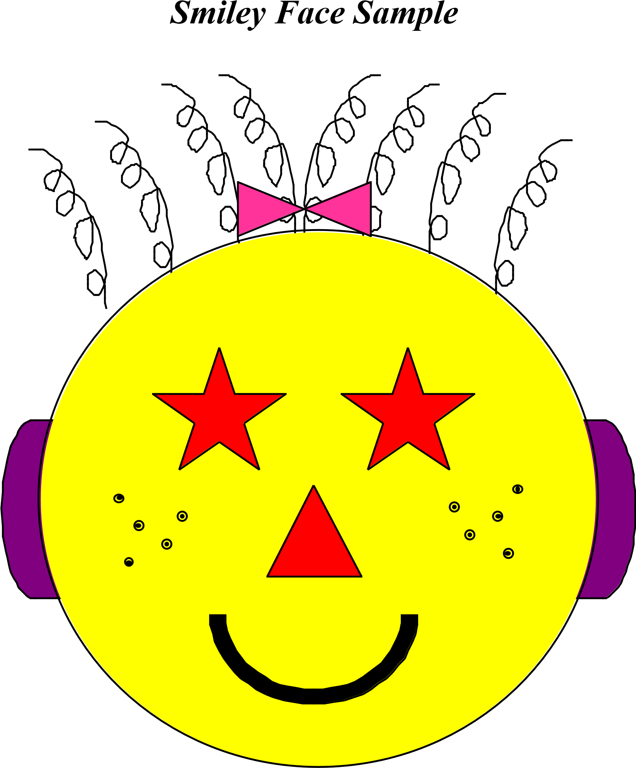
Name: Susie Jo Smiley
Parent: Sue Jo Smith
1st Hour
Genetics with a Smile Name _________________________________
Part A: Smiley Face Traits
- Obtain two coins from your teacher. Mark one coin with a “F” and the other with a “M” to represent each of the parents. The parents are heterozygous for all the Smiley Face traits.
- Flip the coins for parent for each trait. If the coin lands with heads up, it represents a dominant allele. A coin that lands tails up indicates a recessive allele. Record the result for each person by circling the correct letter. Use the results and the Smiley Face Traits page to determine the genotype and phenotype for each trait.
Trait | Female | Male | Genotype | Phenotype
Face Shape | C c | C c
Eye Shape | E e | E e
Hair Style | S s | S s
Smile | T t | T t
Ear Style | V v | V v
Nose Style | D d | D d
Face Color | Y y | Y y
Eye Color | B b | B b
Hair Length | L l | L l
Freckles | F f | F f
Nose Color | R Y | R Y
Ear Color | P T | P T
Part B: Is it a boy or girl?
To determine the sex of your smiley face, flip the coin for the male parent. Heads would represent X, while tails would be Y.
 | Female | Male | Genotype | Phenotype
Sex | X | X Y
Part C: Create Your Smiley Face!
Use the Smiley Face Traits chart and your results from Part A to create a sketch of your smiley face in the box. Once you have completed the sketch, use the drawing tools in Microsoft Word to create your smiley face! Two things to remember ...
√ Do not add color on the computer! Print a black and white copy and then use crayons or colored pencils to finish it.
√ Don’t forget to give your smiley face a name! You will also need to include your name as parent and your class hour.

Genetics with a Smile

Smiley Face Traits

Face Shape
Circle (C) Oval (c)

Eye Shape
Star (E) | Blast (e)

Hair Style
Straight (S) | Curly (s)
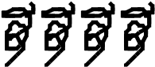
Smile
Thick (T) | Thin (t)

Ear Style
Curved (V) | Pointed (v)

Nose Style
Down (D) Up (d)

Face Color | Eye Color
Yellow (Y) | Blue (B)
Green (y) | Red (b)
Hair Length | Freckles
Long (L) | Present (F)
Short (l) | Absent (f)
Nose Color | Ear Color
Red (RR) | Hot Pink (PP)
Orange (RY) | Purple (PT)
Yellow (YY) | Teal (TT)

Sex
To determine the sex, the flip the coin for the male parent. Heads equals X and tails equals Y.
XX - Female - Add pink bow in hair
XY - Male - Add blue bow in hair

Genetics with a Smile Name _________________________________ Wrapping It Up!
- How does your smiley face compare to the ones created by your classmates? Pick two smiley faces that are displayed near your smiley face and compare each of the 12 traits. Indicate the phenotype for each smiley face for each trait in the chart.
Trait | My Smiley Face | Smiley by ____________ | Smiley by ____________
Face Shape
Eye Shape
Hair Style
Smile
Ear Style
Nose Style
Face Color
Eye Color
Hair Length
Freckles
Nose Color
Ear Color
- Which smiley face has the most dominant traits? _____________________ How many? ______ traits
- Which smiley face has the most recessive traits? _____________________ How many? ______ traits
- Which traits were a result of incomplete dominance?
- What is the probability that a smiley face will have a green face? _____ out of _____ or ____ %
- How many smiley faces have a green face, which is a recessive trait? _____ out of _____ or ____ %
- How does your predicted probability for a green face (#5) compare to the actual results (#6)? Explain.
- What is the probability that a smiley face will have an orange nose? _____ out of _____ or ____ %
- How many smiley faces have an orange nose? _____ out of _____ or ____ %
- How does your predicted probability for an orange nose (#8) compare to the actual results (#9)? Explain.
- Why did you only need to flip the male parent coin to determine the sex of your smiley face?
- How would the smiley faces change if one of the parents were homozygous dominant for all the traits while the other was heterozygous?
- How would the smiley faces change if one of the parents were recessive for all the traits while the other was heterozygous?
- Uncle Smiley, who is heterozygous for a yellow face, married a woman with a green face. Both of them have always wanted a large family! If they were to have 12 children, what is the probability that the children would have yellow faces? How many would have green faces? Create a Punnett square to to help you find your answers.
- Grandma and Grandpa Smiley are heterozygous for the star eye shape. If one of their heterozygous children married a girl with blast-type eyes, what percentage of their grandchildren should have starry eyes? What percent would have blast-type eyes? Create a Punnett square to help you find your answers.
- Baby Smiley has curly hair, but neither of her parents do! Is this possible? Create a Punnett square to help you find your answer.
- Aunt Smiley has the cutest pointed ears and would love to have children with pointed ears! What type of ears would her husband need to have in order for her to get her wish? Give the genotype and phenotype as part of your answer.

Genetics with a Smile - Wrapping It Up! Answer Key
- How does your smiley face compare to the ones created by your classmates? Pick two smiley faces that are displayed near your smiley face and compare each of the 12 traits. Indicate the phenotype for smiley face for each trait in the chart! Answers will vary.
Trait | My Smiley Face | Smiley by ____________ | Smiley by ____________
Face Shape
Eye Shape
Hair Style
Smile
Ear Style
Nose Style
Face Color
Eye Color
Hair Length
Freckles
Nose Color
Ear Color
- Which smiley face has the most dominant traits? ________________________ How many? ______ traits^{Answers will vary.XXXXXXXXXXX}
NameXXXXXXXXXXXXXXXX the person who created the
- Which smiley face has the most recessive traits? ________________________ How many? ______ traitsXXXXXXXXXXXXXXXsmiley face for the answers.
- Which traits were a result of incomplete dominance?
XXXXXXXXXXXXXXXXXThe “yy” genotype would appear in
XXXXXXXXXXXXXXXNose color and ear color XXXXXXXXXXXXXXXXXX1 out of 4 boxes of a punnett square.
- What is the probability that a smiley face will have a green face? ____ out of ____ or ____ %XX1 XX4 XX25
Answers will vary.XXXXXXXXXXX
- How many smiley faces have a green face, which is a recessive trait? ____ out of ____ or ___ %
- How does your predicted probability for a green face (#5) compare to the actual results (#6)? Explain.
Answers will vary.XXXXXXXXXXX
- What is the probability that a smiley face will have an orange nose? ____ out of ____ or ____ %XX2 XX4 50XX
Answers will vary.XXXXXXXXXX The “RY” genotype would appear in XXXXXXXXXXXXXXXXX
- How many smiley faces have an orange nose? ____ out of ____ or ___ % 2XXXXXXXXXXXXXXXXX out of 4 boxes of a punnett square.
- How does your predicted probability for an orange nose (#8) compare to the actual results (#9)? Explain.
Answers will vary.XXXXXXXXXXX

Genetics with a Smile - Wrapping It Up! Answer Key p 2
- Why did you only need to flip the male parent coin to determine the sex of your smiley face?
XXXXXXXXXXXXXXXXXXXXXXXXXXXXXXXXXXXXXXXXXXXXXXXXXXXXXXXXXXXXXXXXXSince the female parent always contributes an X, the male determines if the smiley will be a female or male and XXXXXXXXXXXXXXXXXXXXXXXXis the only coin that needs to be flipped.
- How would the smiley faces change if one of the parents were homozygous dominant for all the traits
while the other was heterozygous? The recessive traits would not be observed in any of the smiley faces.XXXXXXXXXXXXXXXXXXXXXXXXXXXXXXXXXXXXXXXXX
- How would the smiley faces change if one of the parents were recessive for all the traits while the other was
heterozygous? The recessive traits would observed more often than if both parents were heterozygous.XXXXXXXXXXXXXXXXXXXXXXXXXXXXXXXXXXXXXXXXXXXXXXXXXXX
- Uncle Smiley, who is heterozygous for a yellow face, married a woman with a green face. Both of them have always wanted a large family! If they were to have 12 children, how many of the children would have yellow faces? How many would have green faces? Create a Punnett square to to help you find your answers.
y y
Yy | yy
Yy | yy
XXXXXXXXXXXXXXXXXXXXXXXXXXXXXXXXXXXXXXXXXXXXXEach child would have a 50% chance of having a yellow face or a green
YXXXXXXXXXXXXXXXXXXXXXXXXXXXXXXXXXXXXXXXXXXXXXface. Out of 12 children, it is likely that they would have 6 with yellow yXXXXXXXXXXXXXXXXXXXXXXXXXXXXXXXXXXXXXXXXXXXXXfaces and 6 with green faces. Since it is a prediction, the actual outcome
XXXXXXmay vary.
- Grandma and Grandpa Smiley are heterozygous for the star eye shape. If one of their heterozygous children married a girl with blast-type eyes, what percentage of their grandchildren should have starry eyes? What percent would have blast-type eyes? Create a Punnett square to help you find your answers.
e e
Ee | Ee
ee | ee
The grandchildren would have a 50% chance of having either eye type. XXXXXXXXXXXXXXXXXXXXXXXXXXXXXXXXXXXXXXXXXXXX
EFifty percent of their grandchildren should have starry eyes and fifty XXXXXXXXXXXXXXXXXXXXXXXXXXXXXXXXXXXXXXXXXXXX percent should have blast-type eyes; however, the actual outcome may vary.XXXXXXXXXXXXXXXXXXXXXXXXXXXXXXXXXXXXXXXXXXXX
e
- Baby Smiley has curly hair, but neither of her parents do! Is this possible? Create a Punnett square to help you find your answer.
S s
SS | Ss
Ss | ss
XXXXXXXXXXXXXXXXXXXXXXXXXXXXXXXXXXXXXXXXXXXXIn order for Baby Smiley to have curly hair, both of her parents would
SXXXXXXXXXXXXXXXXXXXXXXXXXXXXXXXXXXXXXXXXXXXXhave to be heterozygous for straight hair (Ss). Baby Smiley had a one in
XXXXXXXXXXXXXXXXXXXXXXXXfour chance (or 25%) to have curly hair. s
- Aunt Smiley has the cutest pointed ears and would love to have children with pointed ears! What type of ears would her husband need to have in order for her to get her wish? Give the genotype and phenotype as part of your answer.
v v v v XXXXXXXXXXXXXXXXXXXXXXXXXXXXXXXXXXXXXXXXXXXXAunt Smiley would have a genotype of “v v” to have pointed ears. She
XXXXXXXXXXXXXXXXXXXXXXXXXXXXXXXXXXXXXXXXXXXXwould have to have a husband who also has a genotype of “v v”, which
vv | vv
vv | vv
Vv | Vv
vv | vv
^{vV}XXXXXXXXXXXXXXXXXXXXXmeans he would have pointed ears. vv
XXXXXXXXXXXXXXXXXXXXXXXXXXXXXXXXXXXXXXXXXXXXIf she had a husband who was heterozygous for curved ears (Vv), she XXXXXXXXXXXXXXXXXXXXXXXXXXXXXXXXXXXXXXXXwould only have a 50% chance of having children with pointed ears.

